**BUILDING FACE DETECTION USING AWS**

PENDELA SAI MANIKANTA

Saimanikanta.pendela@vitap.ac.in

**LOGIN PAGE**

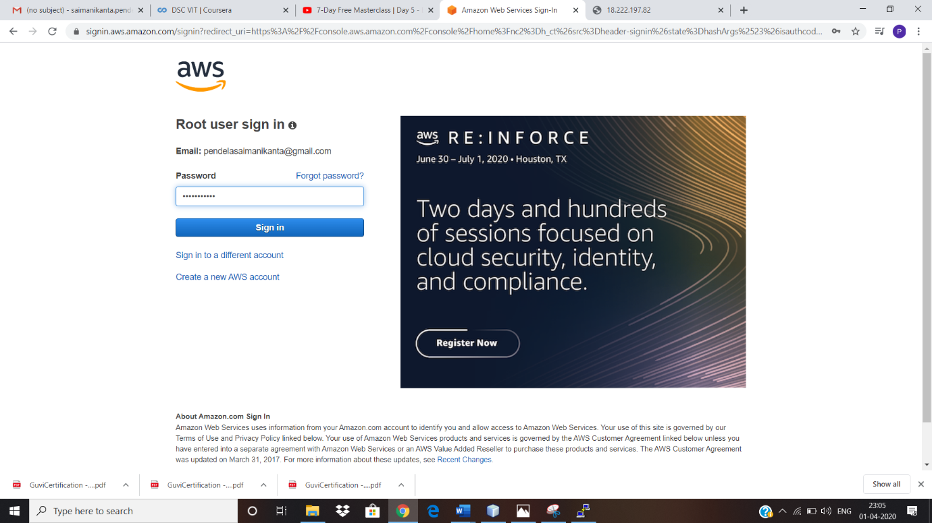

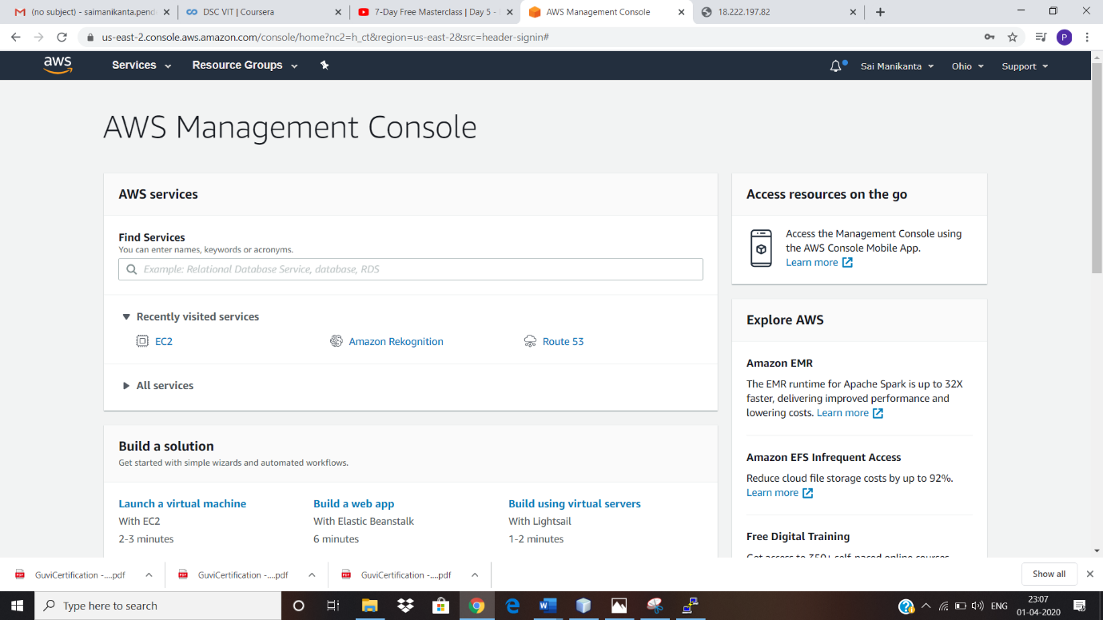

**EC2 DASHBOARD**

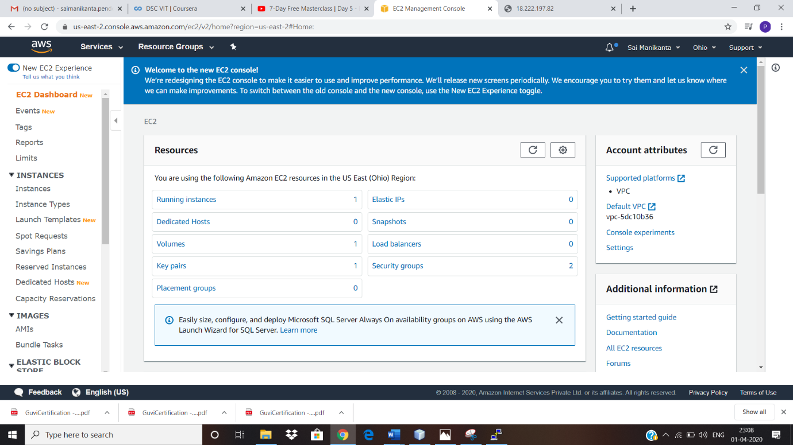

**S3 DASHBOARD**

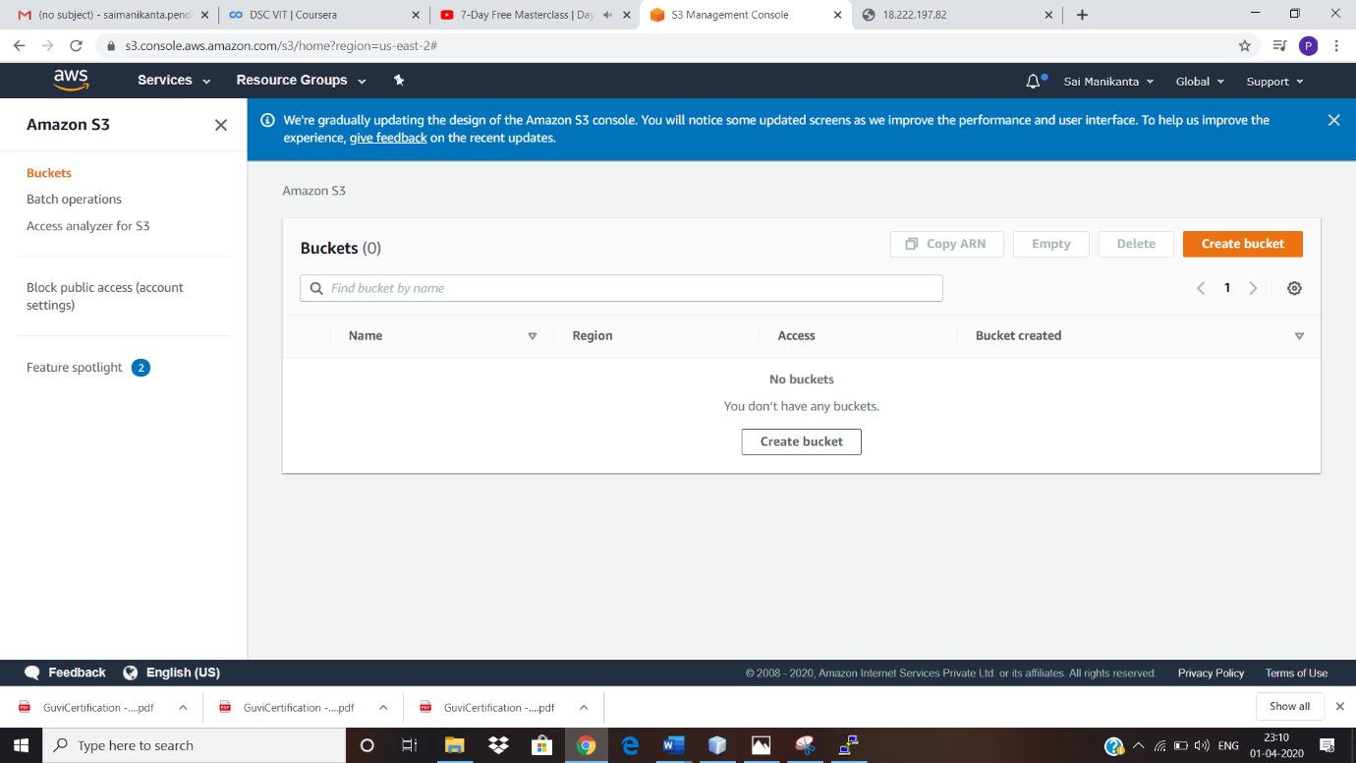

**REKOGNITION DASHBOARD**

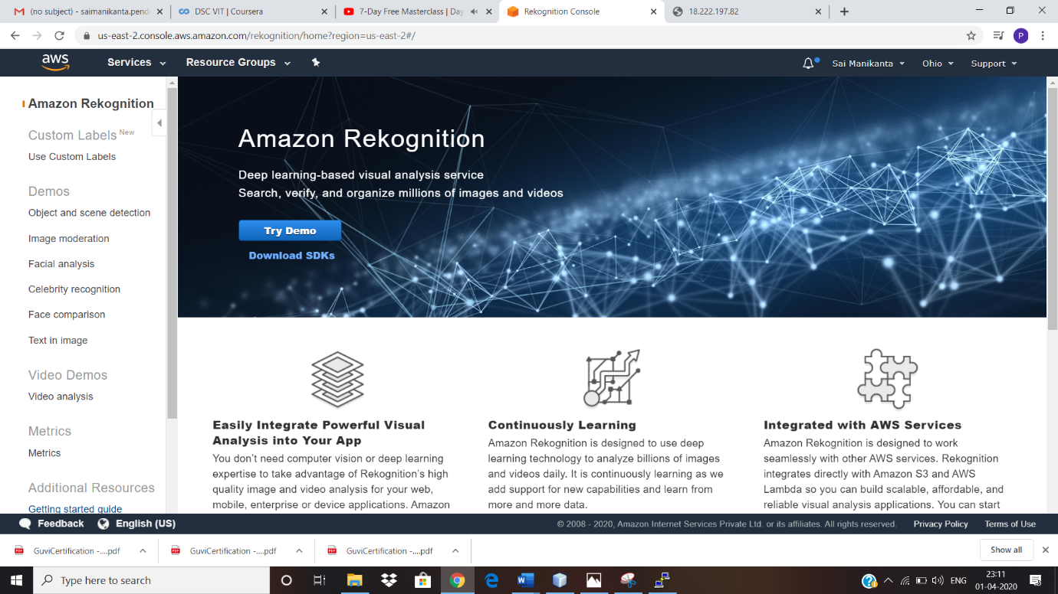

**SCREENSHOTS OF EC2**

**CHOOSING AN AMI**

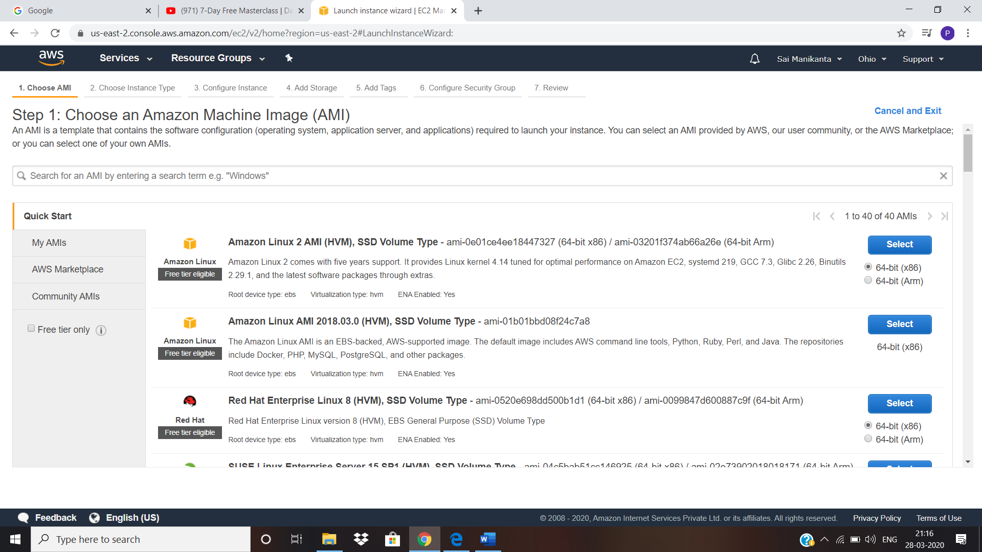

**CHOOSING AN INSTANCE TYPE**

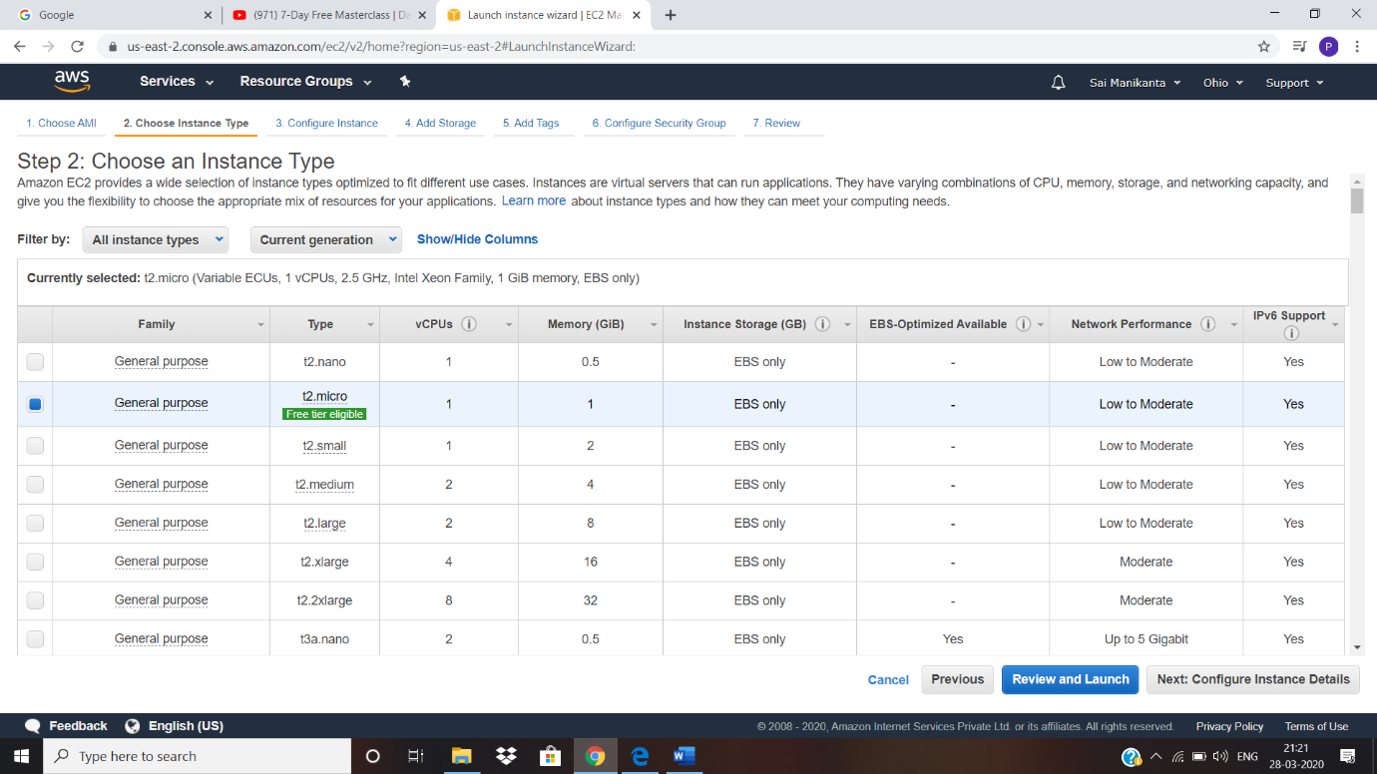

**ADDING STORAGE**

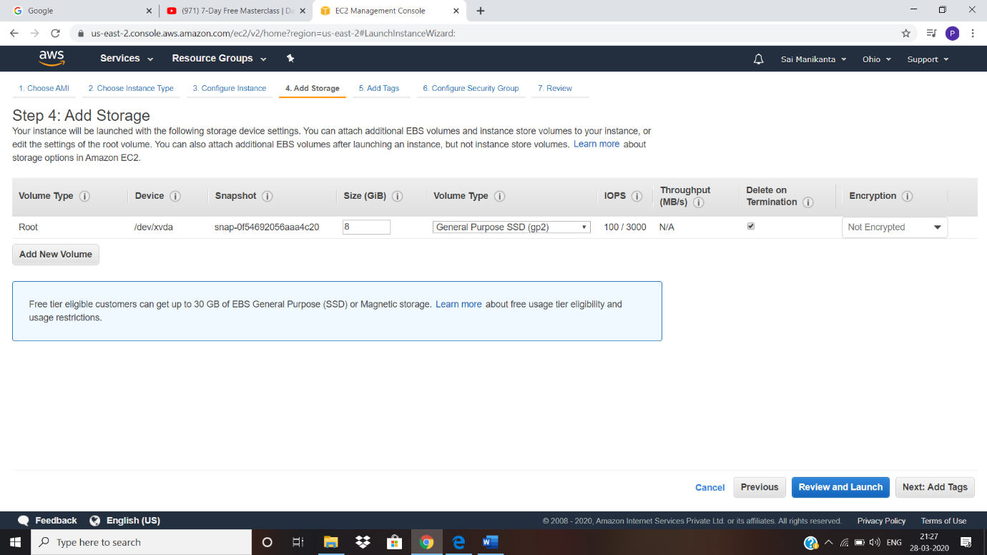

**CONFIGURING SECURITY GROUP**

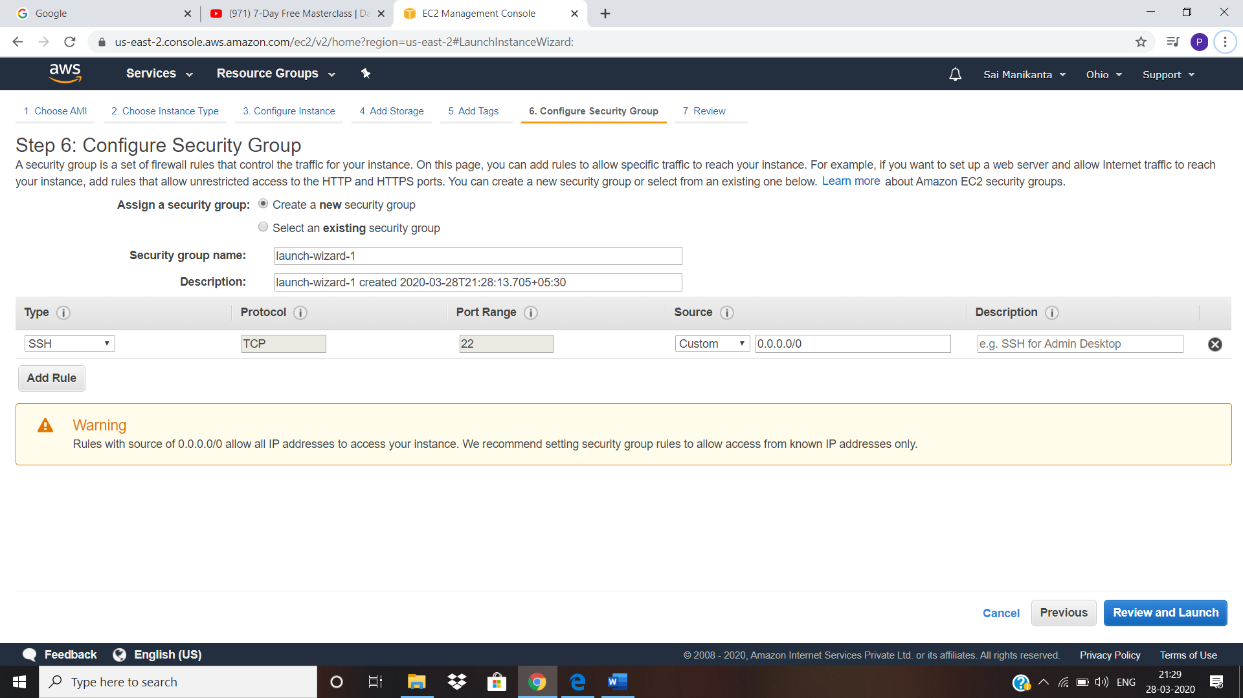

**KEY PAIR DOWNLOAD**

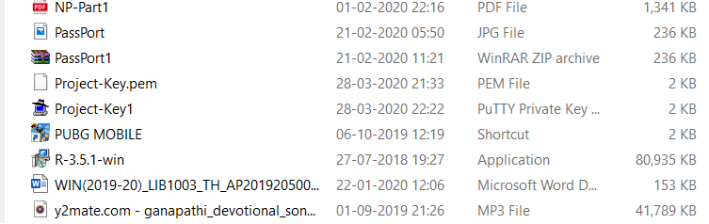

**PUTTYGEN CONVERSION FROM PPM TO PPK**

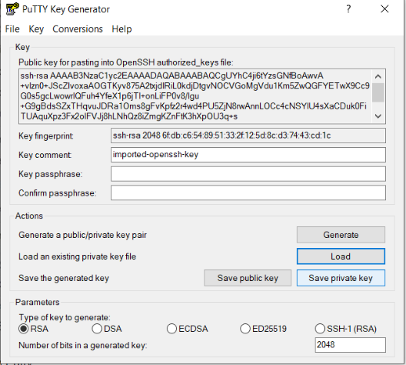

**LOGGED INTO EC2 BLACK SCREEN**

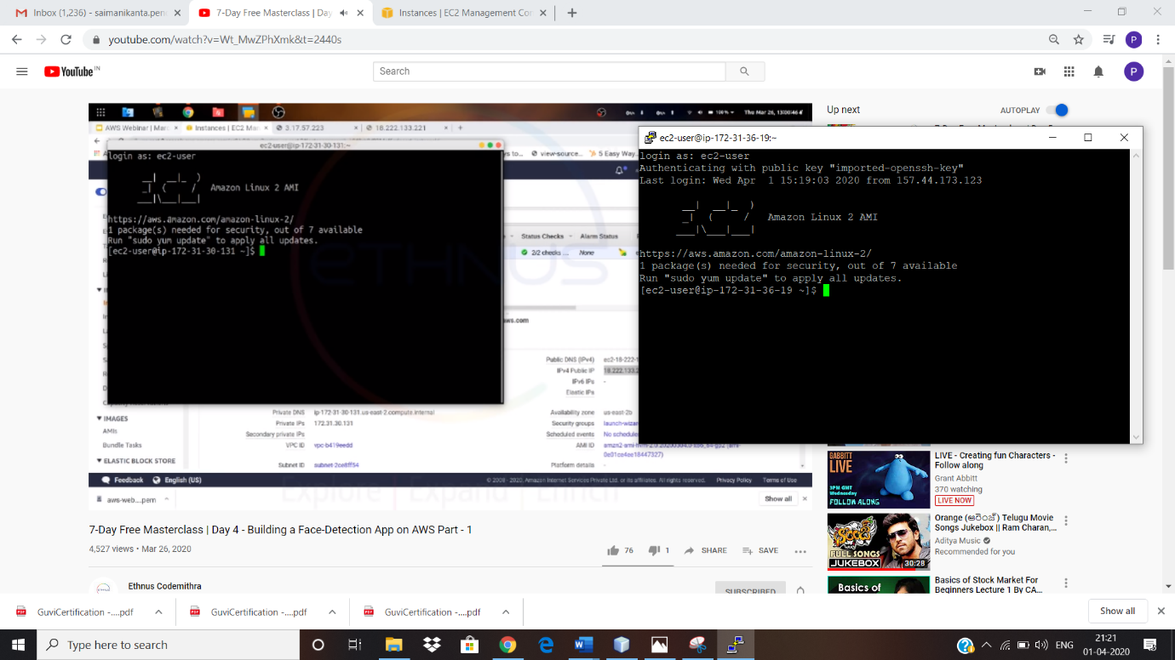

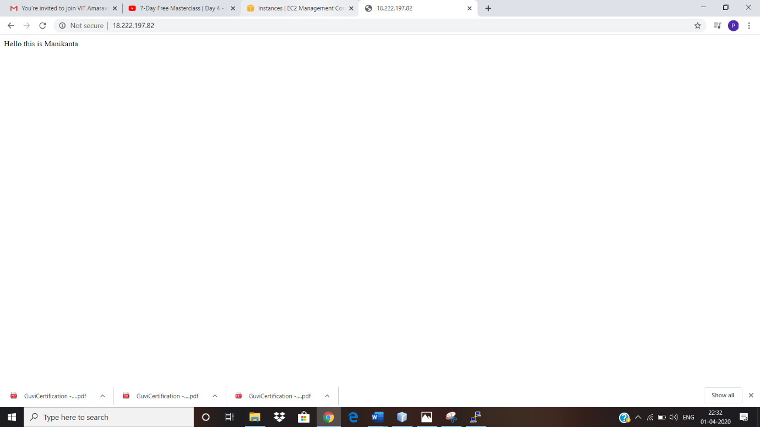

**SCREEN SHOTS OF S3**

**CREATING BUCKET**

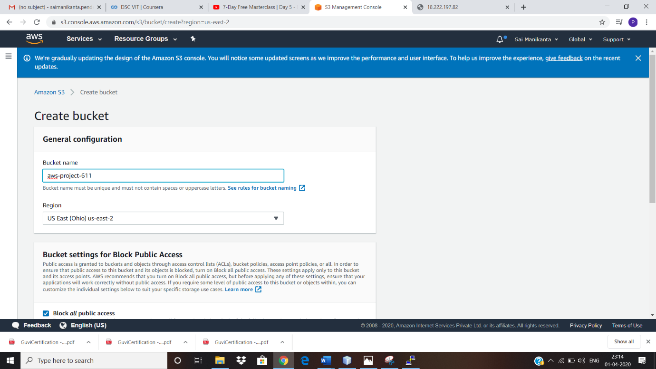

**UPLOADING AN OBJECT**

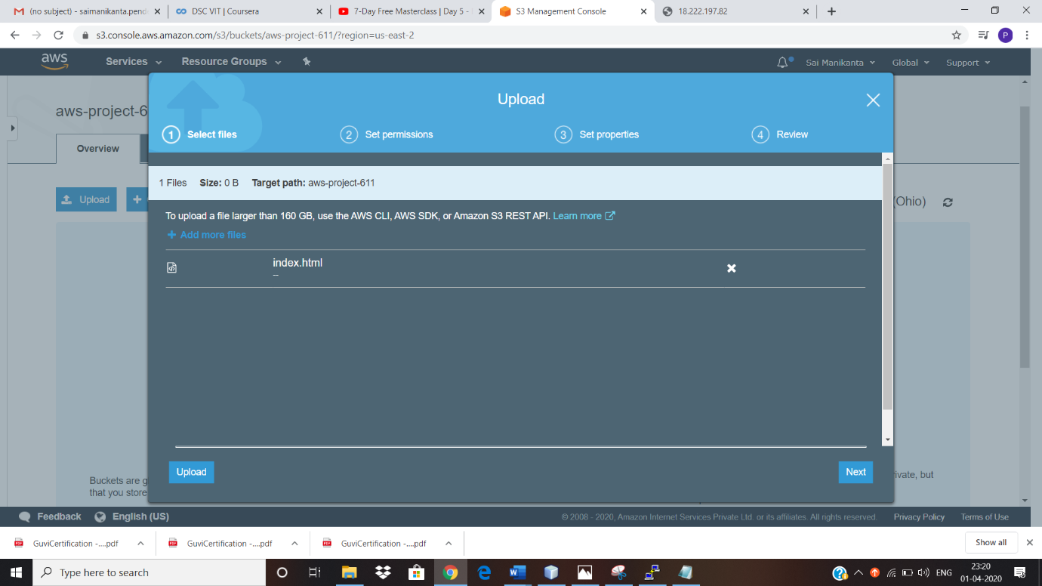

**ENABLING STATIC WEBSITE**

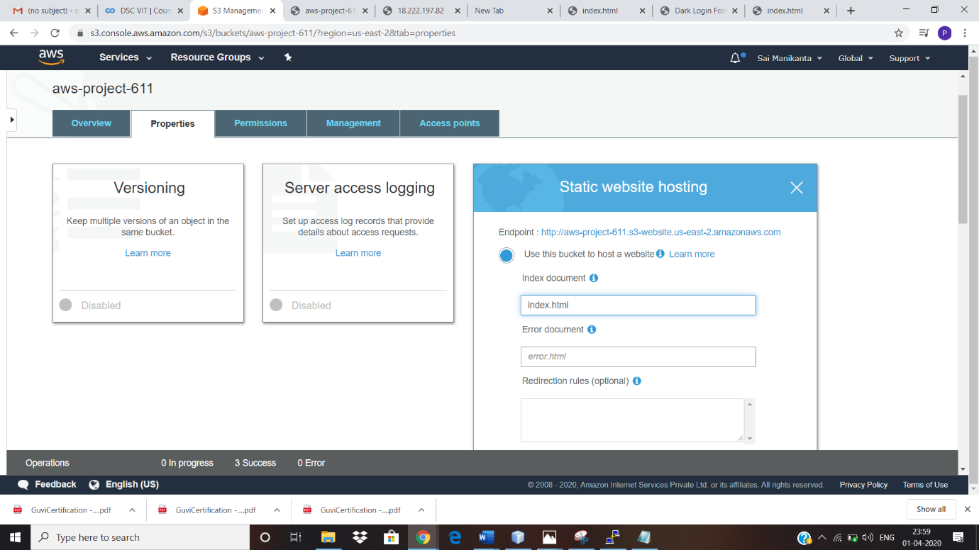

**MAKE THE OBJECT PUBLIC**

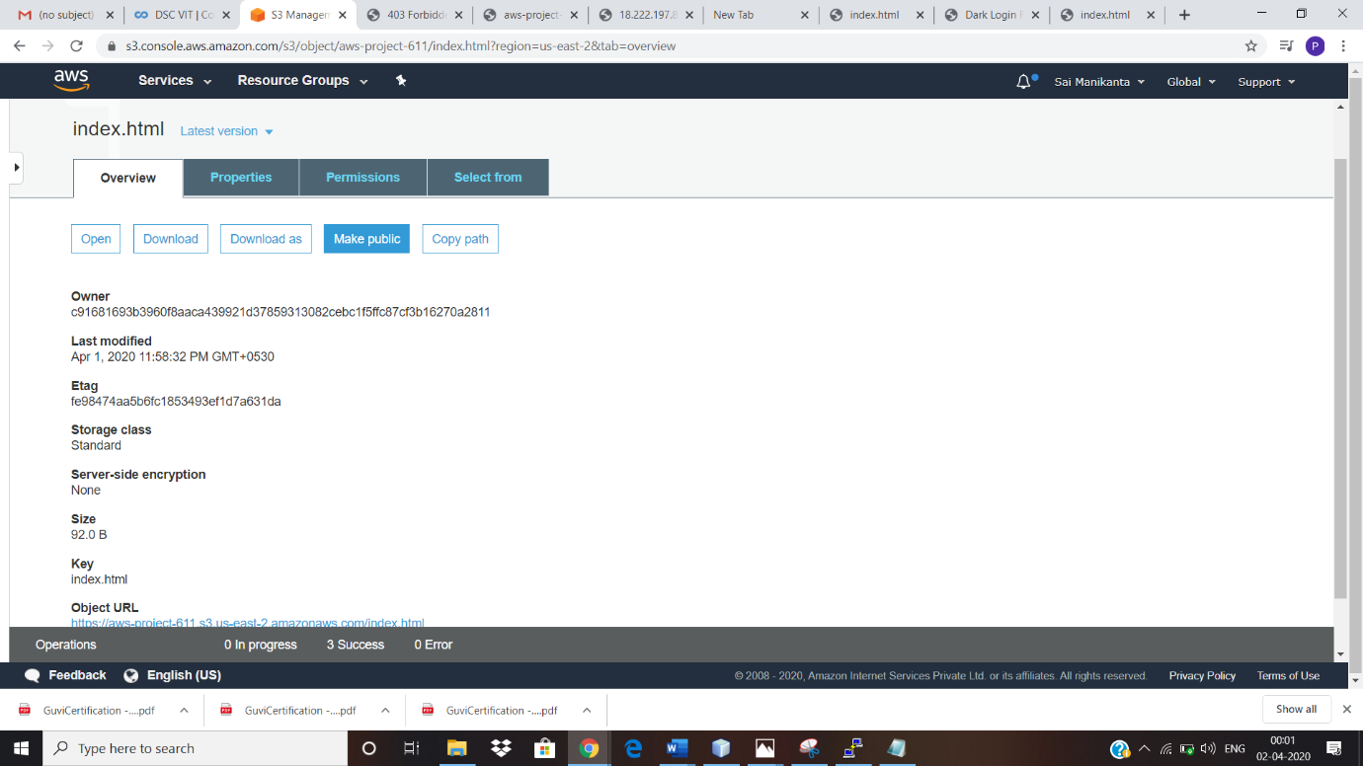

**CHECKING THE S3 LINK OF BROWSER**



**REKOGNITION SCRENSHOTS**

**FACIAL ANALYSIS**

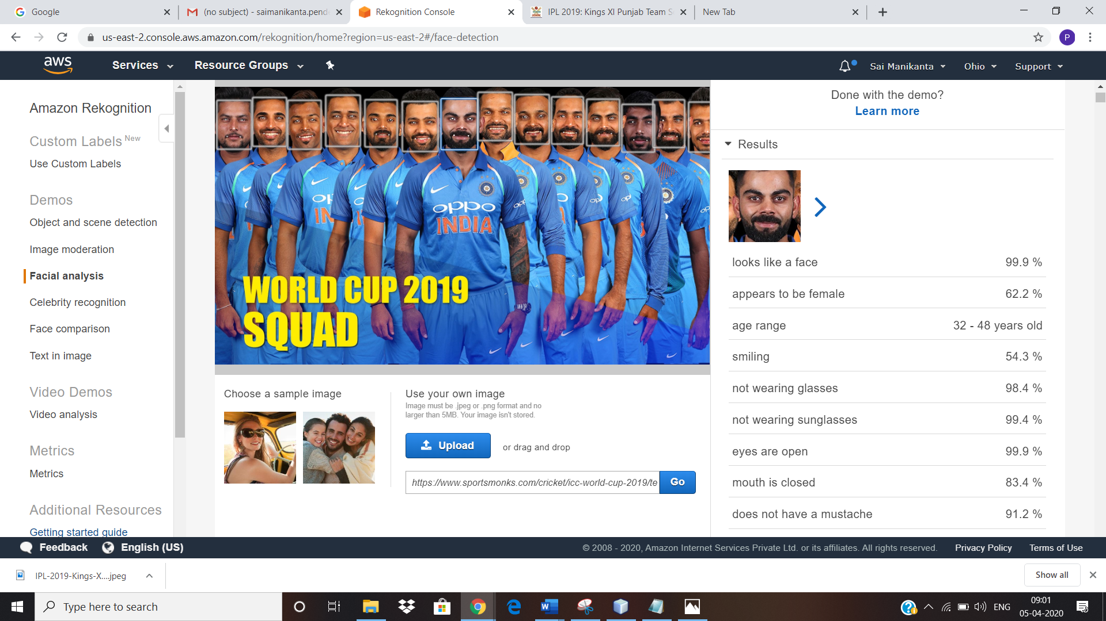

**FACE COMPARISION**

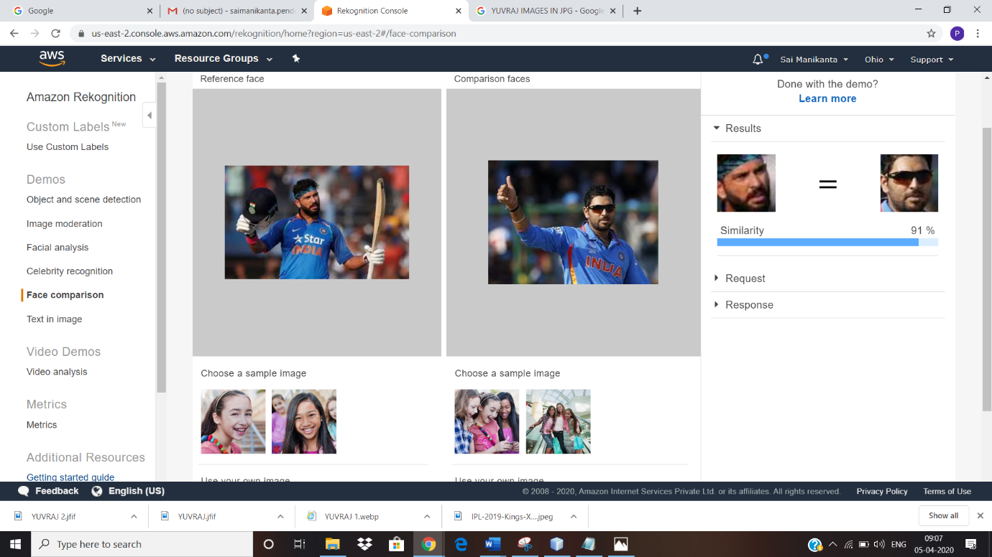

CELEBRITY REKOGNITION

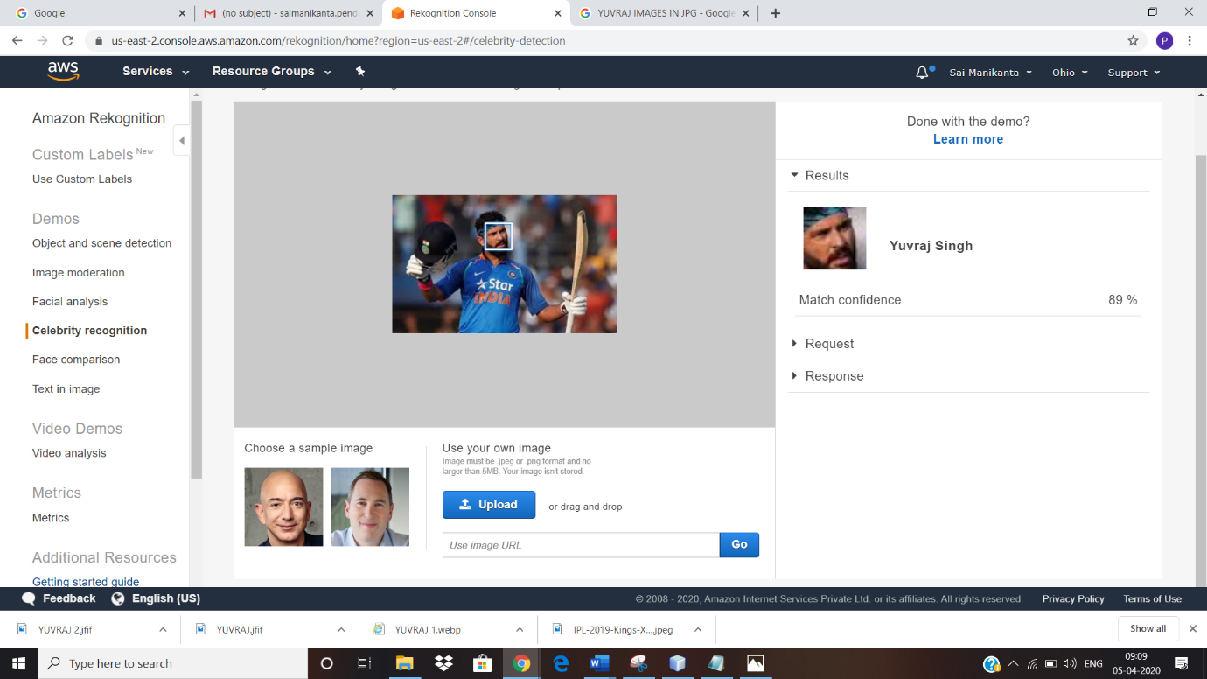

**TEXT IN IMAGE**

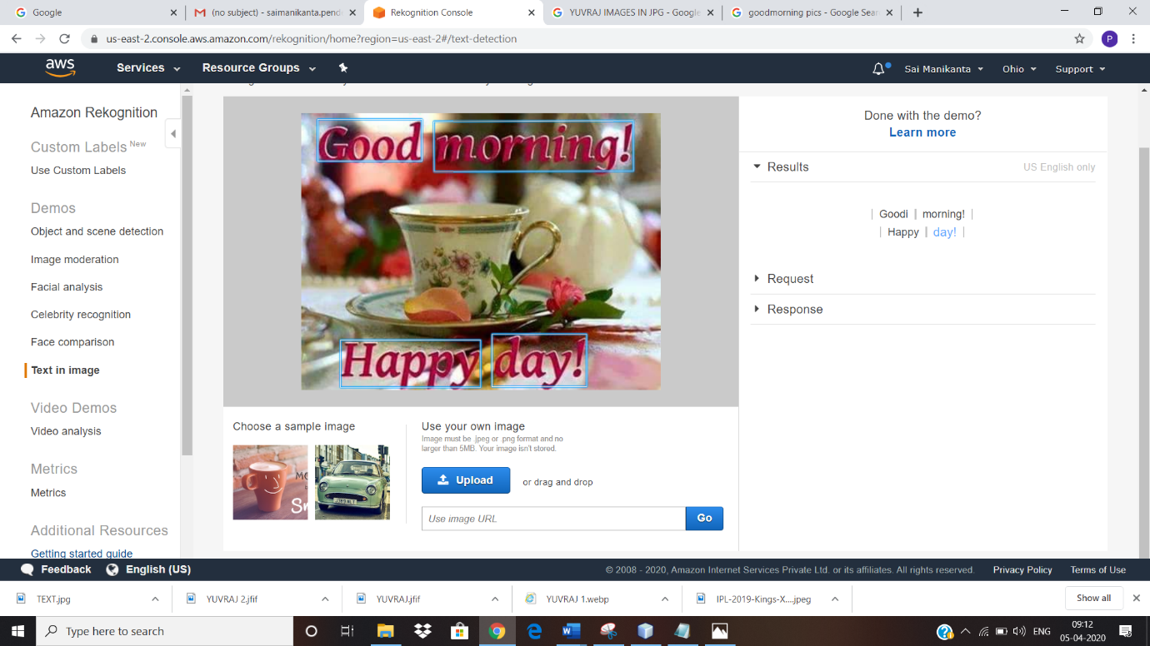

**EC2 AND S3 SCREEN SHOTS**

**INSTALING AWS-SDK**

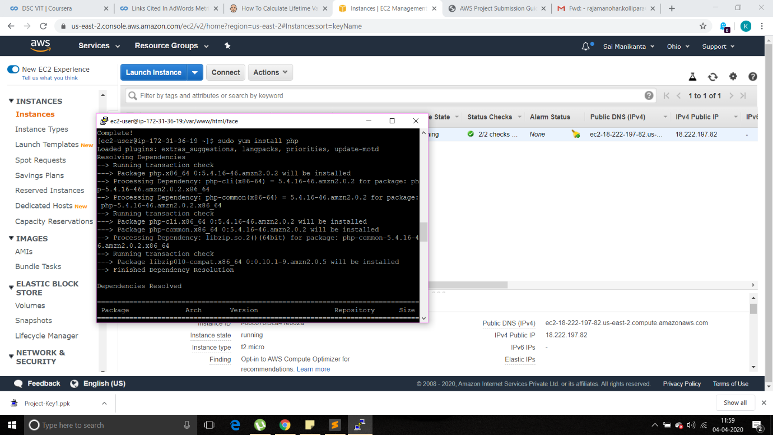

**INSTALLING PHP**

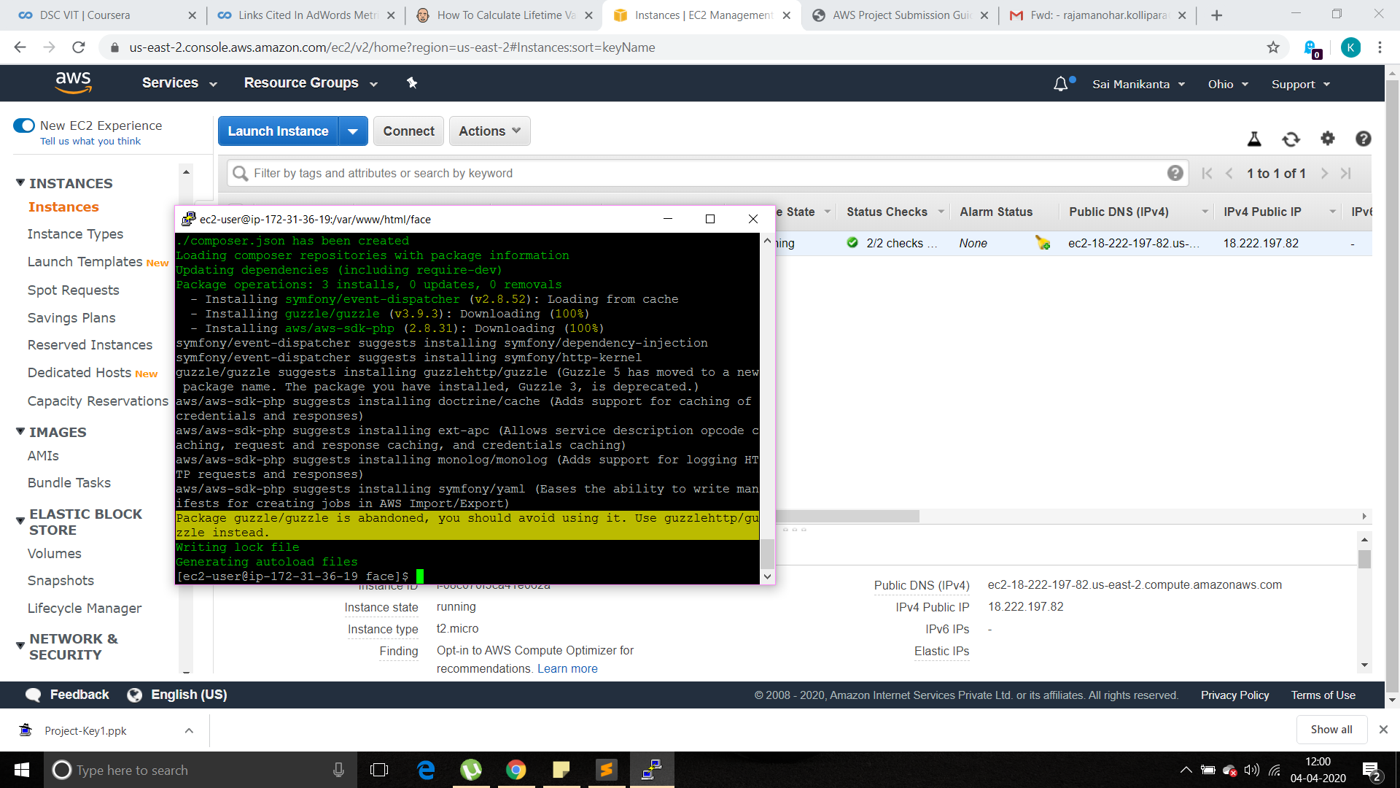

**Index.php FILE CODE**

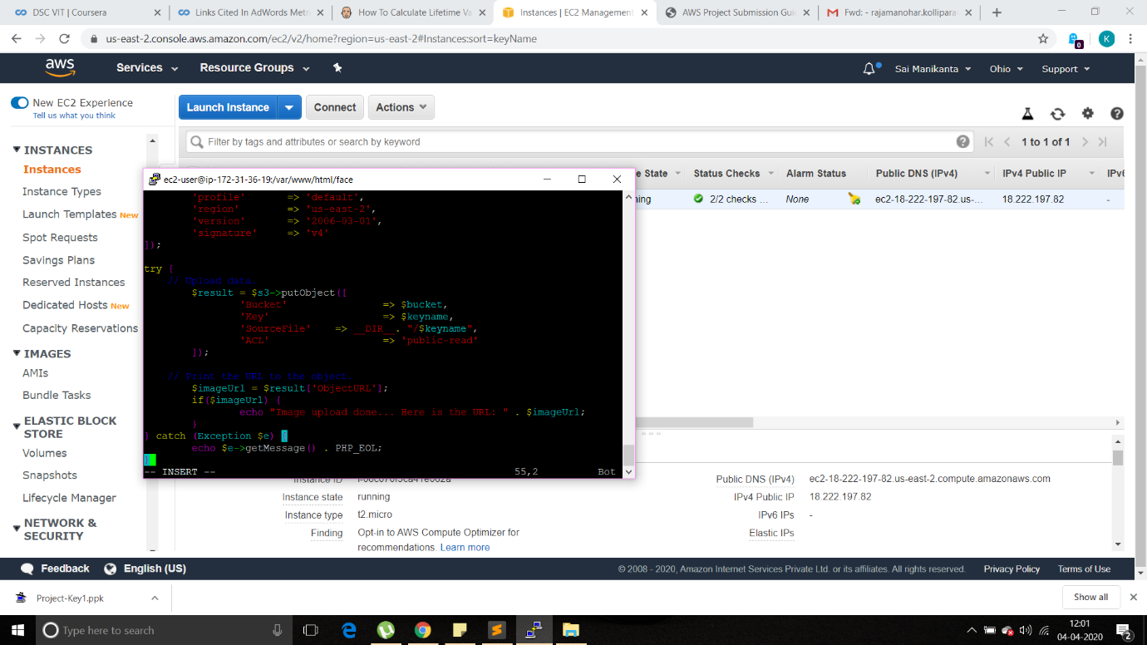

**UPLOAD SUCCESS SCREENSHOT**

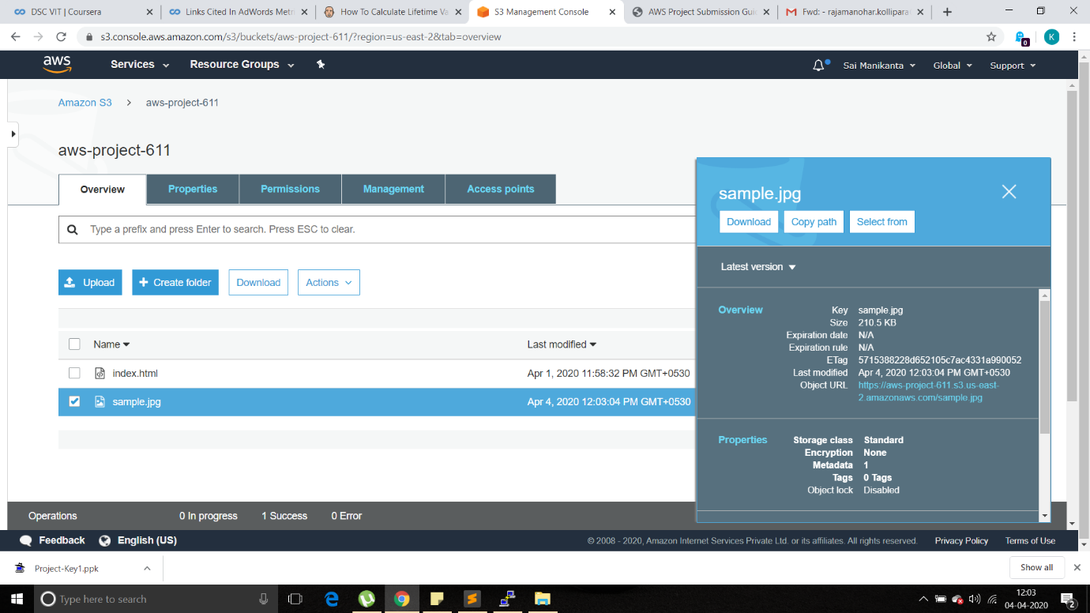

**EC2 AND FACE REKOGNITION**

**FACE DETECT SUCCESS SCREEN SHOT**

